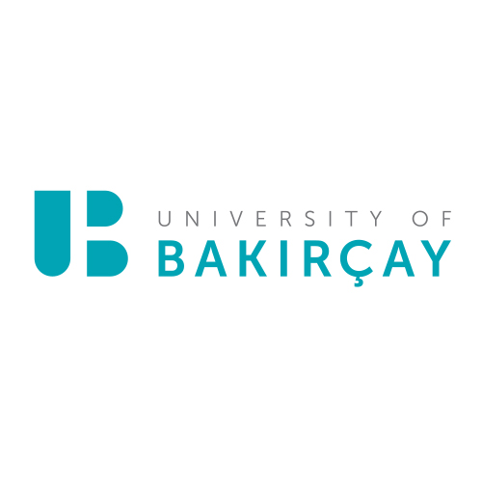

IZMIR BAKIRCAY UNIVERSITY
SUSTAINABILITY REPORT
2023

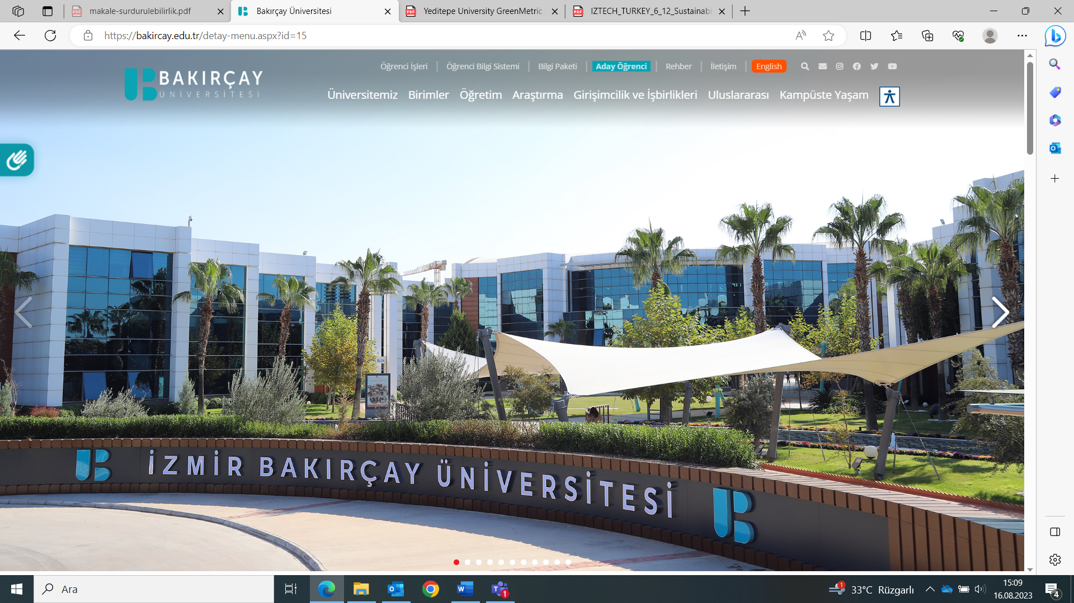

CONTENTS
ABSTRACT
1. INTRODUCTION
2. CAMPUS SETTING AND INFRASTRUCTURE
3. ENERGY AND CLIMATE
4. WASTE
5. WATER
6. TRANSPORTATION
7. EDUCATION AND RESEARCH

ABSTRACT
In order to create a strong institutional image and sustain their presence, many universities around the world are placing greater importance on sustainability efforts, taking into account the global context, environment, and society in which they operate. Universities that integrate sustainability activities into their work within this framework enhance their visibility within society and thus, with the competitive advantage they possess, they can benefit in the long term.
The green management approach, which operates without using natural resources and causing harm to the environment and people, emerged in the 1990s. Universities that have adopted sustainability are referred to by various names such as "green campus," "eco-campus," "sustainable campus," "environmentally friendly university," or "sustainable university." The concept of a Green University encompasses a broad range of activities, including curriculum, research projects, publications, environmental student clubs, research centers, and institutes, as well as public awareness campaigns.
İzmir Bakircay University as a leading institution in many subjects has adopted the mission of supervising the society in environmental awareness and sustainability issues. In this context, the Ecological University Coordinatorship was established in our university with the directive of creating an environmentally friendly and sustainable campus area by ensuring energy efficiency and sustainability by utilizing smart technologies and automation systems and meeting its energy demand by using clean and renewable energy systems such as wind and photovoltaic systems installed at the campus. It also aims to be certified by national and international accredited organizations such as GreenMetric and Leed.

1. INTRODUCTION
The main campus of İzmir Bakırçay University is located in Seyrek village of İzmir in Turkey. It was built on a total area of 140,000 m² of which 65,000 m² was allocated for buildings/facilities and 75,000 m² is open area. The university which was founded on 20th August 2016 has a history of about seven years. There are seven Faculties (Faculty of Humanity and Social Sciences, Faculty of Law, Faculty of Economics and Administrative Sciences, Faculty of Engineering and Architecture, Faculty of Health Sciences, Faculty of Medicine, and Faculty of Pharmacy). There is one School of Foreign Languages, two vocational schools (Vocational School of Justice and Menemen Vocational School) and there is one Graduate Education Institution. The university started education in 2016 with the slogan of "A Private State University" with 850 students. As of year 2023, there are 7395 students, 387 academic and 213 administrative staff at the university. Academic activities for international cooperation in İzmir Bakırçay University are supported by special programs such as Erasmus+ in line with the strategic plan. Our university has also bilateral cooperation and exchange agreements called Memorandum of Understanding with several institutions from different countries who are not involved in the Erasmus+ Network.
Izmir Bakircay University has adopted continuous improvement as an innovative educational institution, aiming international recognition and respect in the fields of education, scientific research, and social service since its foundation in 2017. In order to achieve this aim, Izmir Bakircay University cooperates scientifically with international universities and organizations and is ready to extend its international networks.
Izmir Bakircay University encourages its academic and administrative units to adopt internationalization policies so that students and employees may gain and share internationalization experiences and fully embrace an internationalization culture.
Besides, the university places a strong emphasis on environmental awareness and sustainability, aligning its activities and goals with the principles of its Sustainable Environmental Policy. There are no architectural restrictions on campus, and special accommodations for disabled individuals are accessible. In recent years, there has been a growing focus on sustainability and ecologically friendly activities as well.
İzmir Bakirçay University as a leading institution in many subjects has adopted the mission of supervising the society in environmental awareness and sustainability issues. In this context, the Ecological University Coordinatorship was established in our university with the directive of creating an environmentally friendly and sustainable campus area by ensuring energy efficiency and sustainability by utilizing smart technologies and automation systems and meeting its energy demand by using clean and renewable energy systems such as wind and photovoltaic systems installed at the campus. It also aims to be certified by national and international accredited organizations such as GreenMetric.

UI GreenMetric is recognized as the world's first rating agency for sustainability. The UI GreenMetric University Sustainability Rating evaluates and compares the sustainability efforts at university campuses worldwide. The evaluation platform was established by the University of Indonesia in 2010 and evaluates participating universities every year.

GreenMetric is a platform that promotes internationalization, raises awareness of sustainability, and tries to promote global awareness for environmental issues. Every year, universities from different countries are evaluated by GreenMetric in areas such as infrastructure, energy and climate change, wastes, water resources, transportation, and education. They are scored for each assessment category and eventually they are ranked according to their total scores from these evaluations. The evaluation is carried out by a team of experts from the University of Indonesia.

The results of UI GreenMetric World University Rankings, which Izmir Bakircay University applied for the first time in 2022, were announced on 12th of December 2022 with an online meeting organized by the University of Indonesia. İzmir Bakirçay University has been ranked 592 out of 1050 universities in the world.

Izmir Bakircay University evaluates its activities on “Sustainability’’ in 6 main categories.

2. CAMPUS SETTING and INFRASTRUCTURE

Sustainable settlements prioritize both the well-being of the environment and the quality of life for humans and other living creatures. Sustainability criteria are applied in the design, maintenance an application of green areas at the campus of Izmir Bakircay University Campus. All campus buildings have green building features such as natural ventilation, full-day natural lighting, and an energy management system.

Among the various factors influencing the quality of life, green spaces stand out as an important parameter. It is crucial to establish and maintain green spaces while establishing a balance between their conservation and utilization to align with the objectives of sustainable development. The main campus of İzmir Bakirçay University has a total open area of about 75000m² of which 16000 m² is defined as landscape. (9000 m² is lawn and 7000 m² is allocated for flowers). Approximately 30,000 plants and 900 trees have been planted at the campus of İzmir Bakirçay University since 2019.
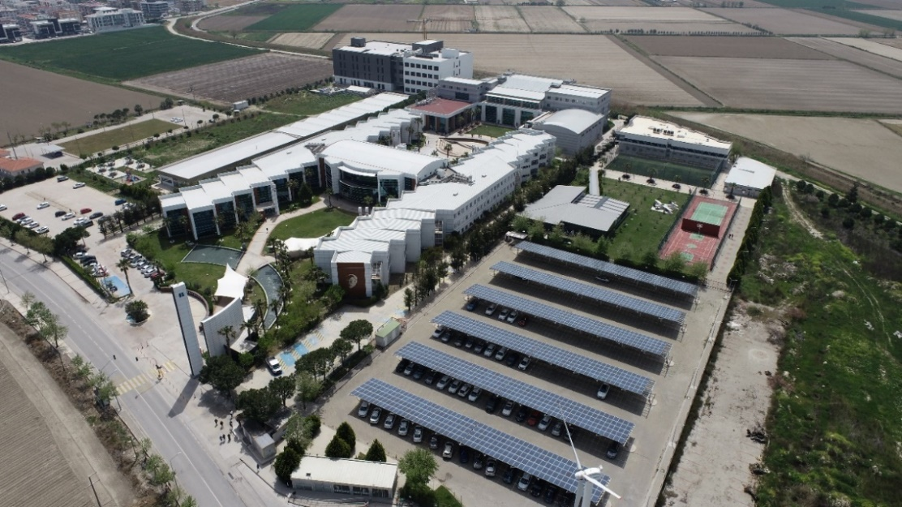
Picture 1: Main Campus Site of İzmir Bakirçay University, Turkey

Design and implementation studies are being carried out in line with the sustainable landscaping approach of the university. Plant species that consume as little water as possible, are suitable for the climate, and add character to the space in every season are preferred, and these plants are arranged in accordance with the principles of landscaping within the campus.

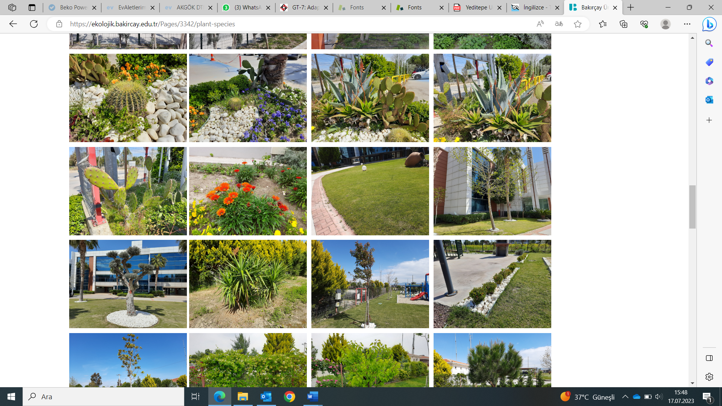

Picture 2: Example of the plant species located at different points on the campus.

Natural stones such as pumice and dolomite are used at the campus of İzmir Bakircay University within the scope of sustainable landscape studies. Pumice and dolomite stones are commonly used materials for cultivating plants. These stones offer various advantages in the plant growing environment.
Pumice stone, with its lightweight and porous structure, allows plant roots to access the oxygen they need. It also retains water effectively and helps meet the plants' water requirements. It allows roots to grow freely and facilitates respiration.

Dolomite stone plays an important role in balancing the pH level in the plant growing medium. Dolomite stone neutralizes acidic pH levels in the soil and ensures a more alkaline environment. This provides a suitable growth medium for many plant species.

Pumice and dolomite stones can be used by placing them near the roots of plants. These stones promote root aeration, retain water, and regulate pH balance. As a result, they create a favorable environment for healthy plant growth and development.
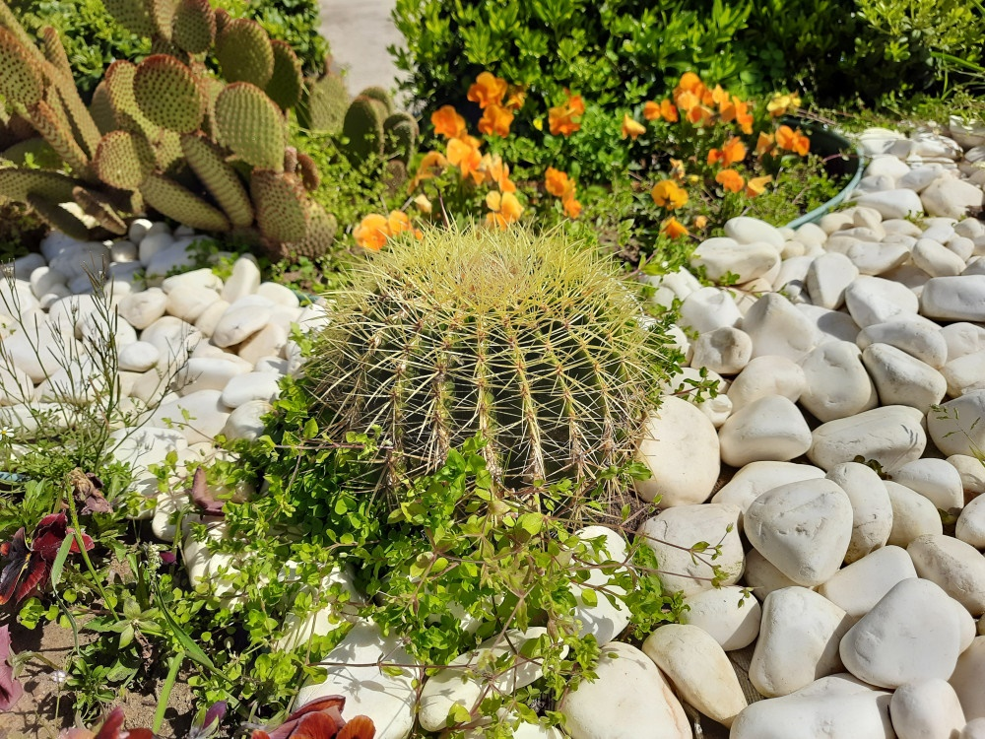

Figure 3: Dolomite stones surrounding the cactus.

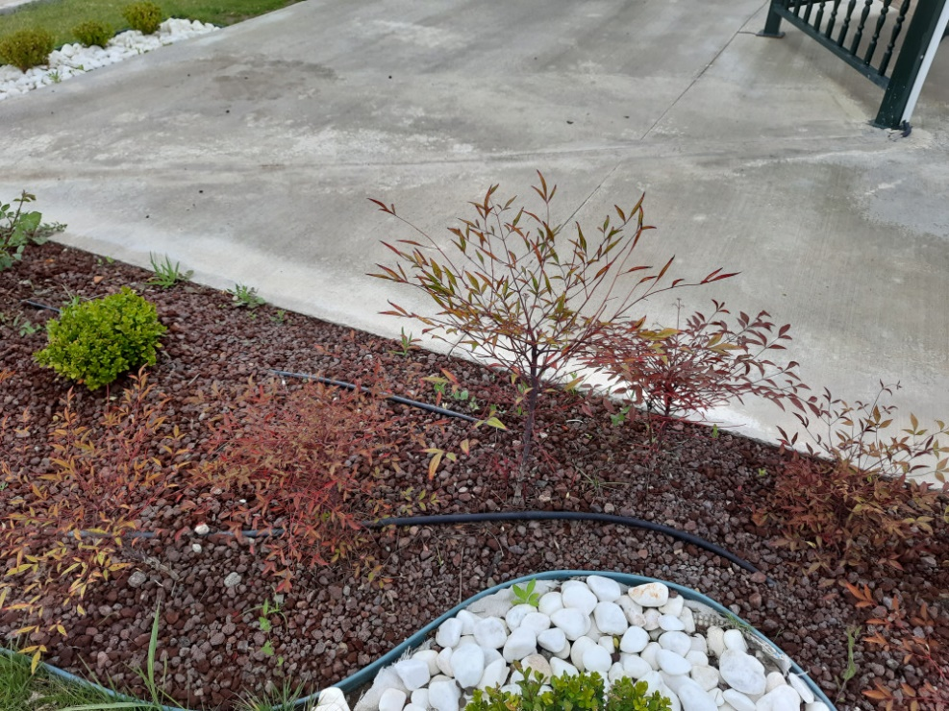

Figure 4: Pumice stones surrounding the Woman's Slipper orchid.

In addition, health infrastructure facilities for students, academics, and administrative staffs wellbeing are available at İzmir Bakircay University Campus Setting. İzmir Bakirçay University has been entitled to receive SAFE CAMPUS CERTIFICATE on 21.07.2022 as it managed to fulfill the requirements of the certification program on the Development of healthy and Clean Environments prepared by the Council of Higher Education and Turkish Standardization institute related to the global Covid-19 pandemic.

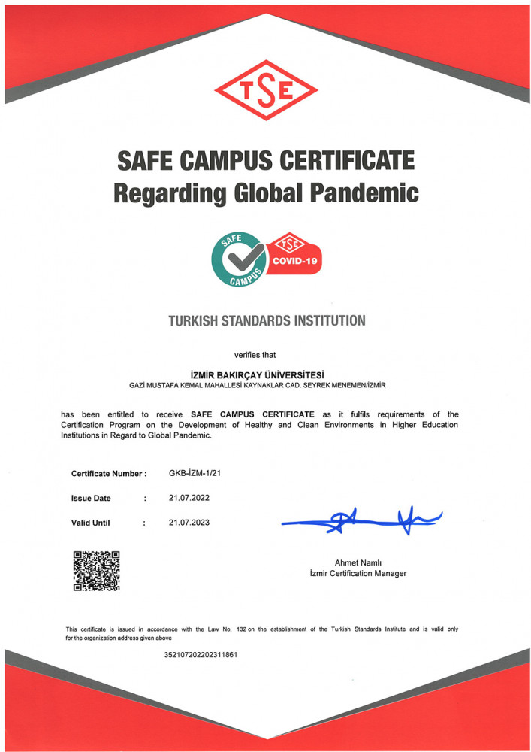
Figure 5: Pumice stones surrounding the Woman's Slipper orchid

The Health Services Unit in the main campus consists of an infirmary with a nurse. Health-related needs that can be met with nursing interventions are determined, planned, and implemented in the institution. In addition, health-related counseling is provided to the personnel and students. Regardless of whether they have a health insurance or not, free of charge service is provided by the infirmary of our university.

At the infirmary of our university services such as blood pressure measurement, blood sugar measurement, wound dressing, minor surgical intervention, first aid, impression of chronic diseases such as diabetes, hypertension, emergency response, are provided.

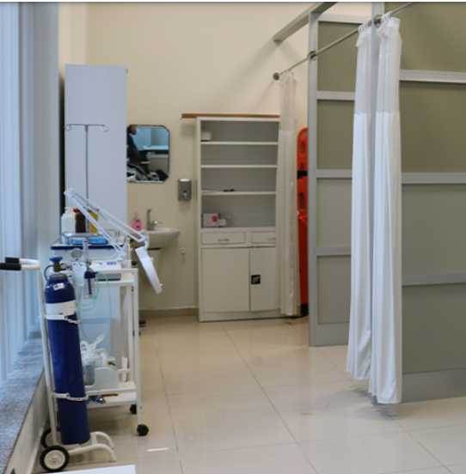

Figure 6: The infirmary at İzmir Bakircay University

İzmir Bakirçay University is affiliated with Cigli Regional Training Hospital which started to serve with the feature of being the first digital hospital in İzmir and has started to provide full-fledged health services since May 21, 2016, with its modern building consisting of 520 bed capacity and 23 blocks, installed on a total are of 70192 m².
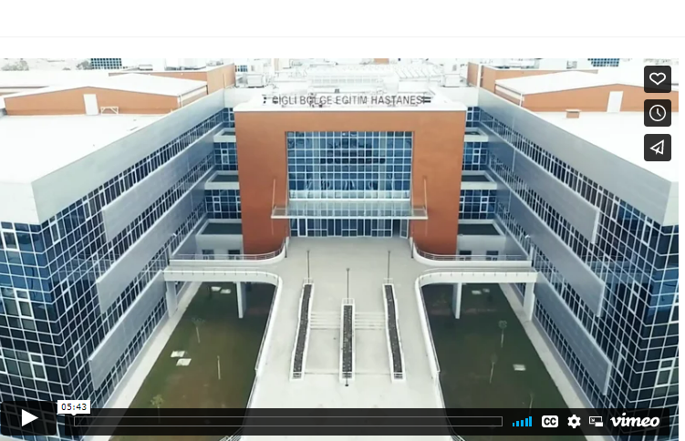
Figure 7: The infirmary at İzmir Bakircay University

Regarding the conservation of plant, animal and wildlife, genetic resources for food and agriculture İzmir Bakircay University recognizes the importance of healthy habitats for human welfare and biodiversity and works to improve the landscape and green area of the campus with an ecosystem approach. It is planned to irrigate all green spaces with rainwater, to provide feasible habitats for living creatures, and strengthen the relationship between nature-animals-human beings.
İzmir Bakircay University recognizes the importance of maintaining and extending existing ecosystems and is working to protect the biodiversity on the campus. In this regard, water-efficient irrigation, innovative landscape design and measures to maintain campus animals are the main concerns İzmir Bakircay University has also a veterinary unit to take care of campus animals. The main objective of the unit is to provide well living conditions for campus animals, which are dogs and cats.

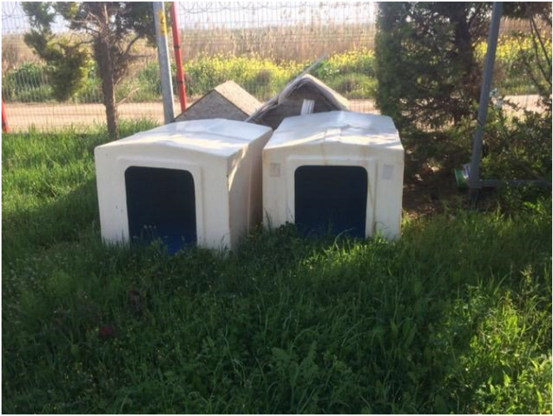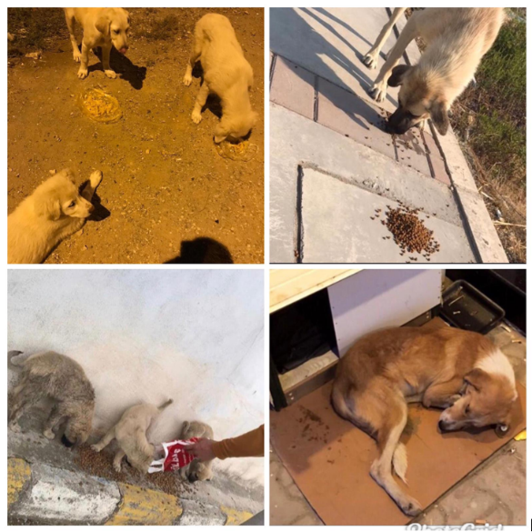
Figure 8: Animal kennels and cats and dogs at the campus of İzmir Bakircay University

Izmir Bakircay University is a disabled-accessible campus, and a peaceful environment is offered to all students to ensure high-quality studies. There are no architectural restrictions on campus, and special accommodations for disabled individuals are accessible. In recent years, there has been a growing focus on sustainability and ecologically friendly activities as well.

Izmir Bakircay University is the first and only barrier-free public university in Izmir. The university participated in the Barrier-Free Education Workshop held in Ankara on May 15th in 2018 organized by the "New Higher Education Council", which aims to raise awareness about the access of disabled individuals in higher education institutions to places, educational opportunities, and socio-cultural activities with the slogans "Access without Barriers" and "Unhindered Education" and to disseminate good practices.

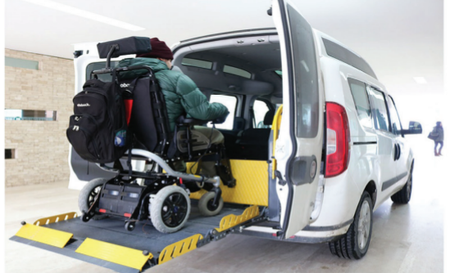
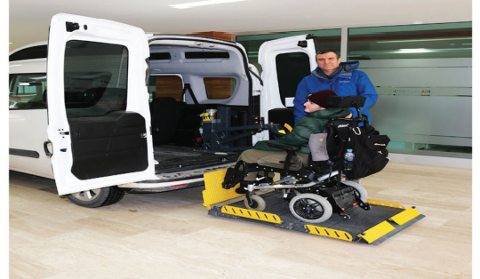

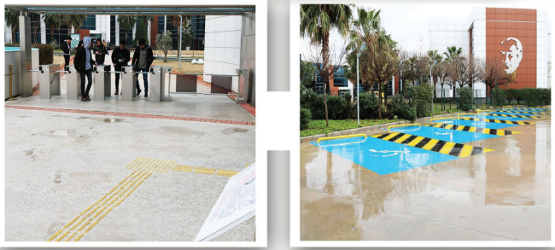
Figure 9: Disabled facilities in the main campus of İzmir Bakırçay University

The university is the first state university where a voice navigation system using Bluetooth technology was installed indoors and outdoors. A visually impaired student can navigate to any point he/she wants to reach in open and closed areas in the campus with a mobile application downloaded to his/her mobile phone, without assistance, with voice commands in the mobile application. The visually impaired students can see all the areas defined specifically for our campus with the application on their mobile phones and can reach their destination with voice guidance by selecting the point they want to go to.
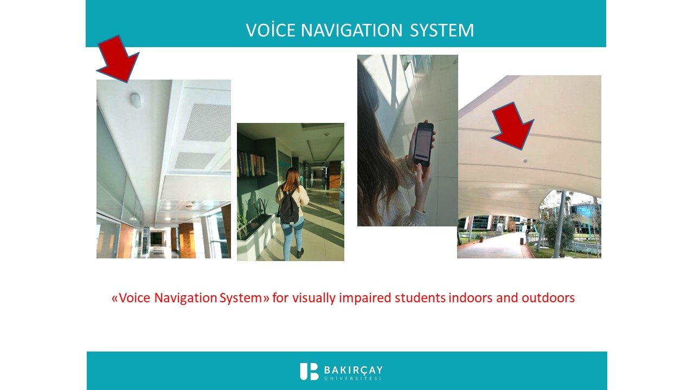
Figure 10: Voice Navigation System for visually impaired students indoors and outdoors

Hearing impaired students are provided with equipment support that is free of charge at the university. “Hearing tests” of our students with hearing problems are performed by the faculty members of our Audiology department at Bakircay University Cigli Training and Research Hospital. Considering their needs and preferences, students are provided with 900 MHz and 2.4 GHz wireless communication technology, Bluetooth-enabled, artificial intelligence supported hearing aids.

3. ENERGY and CLIMATE CHANGE

Izmir Bakircay University aims to meet its entire annual energy needs from renewable energy sources such as solar and wind. Furthermore, as part of energy efficiency efforts, work has been carried out to detect energy leaks in buildings and address these leaks through architectural and constructional solutions

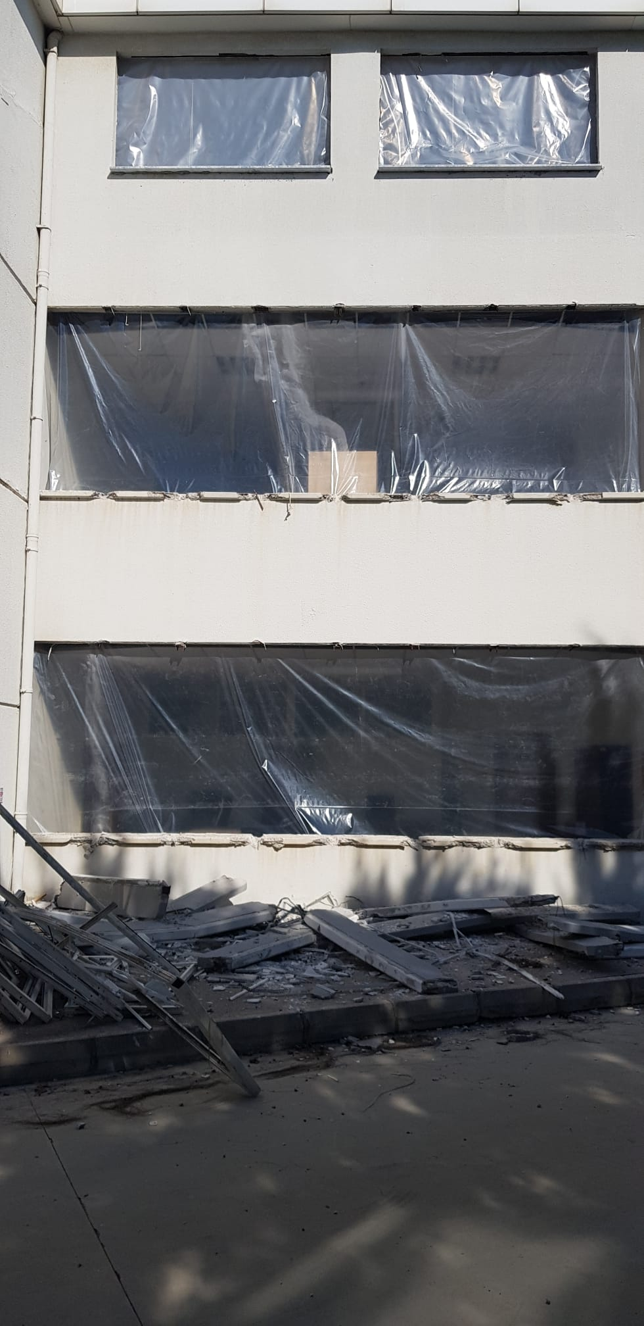
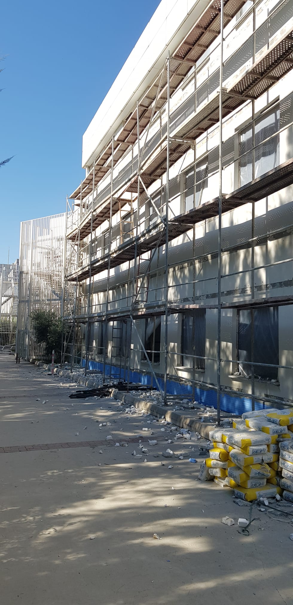
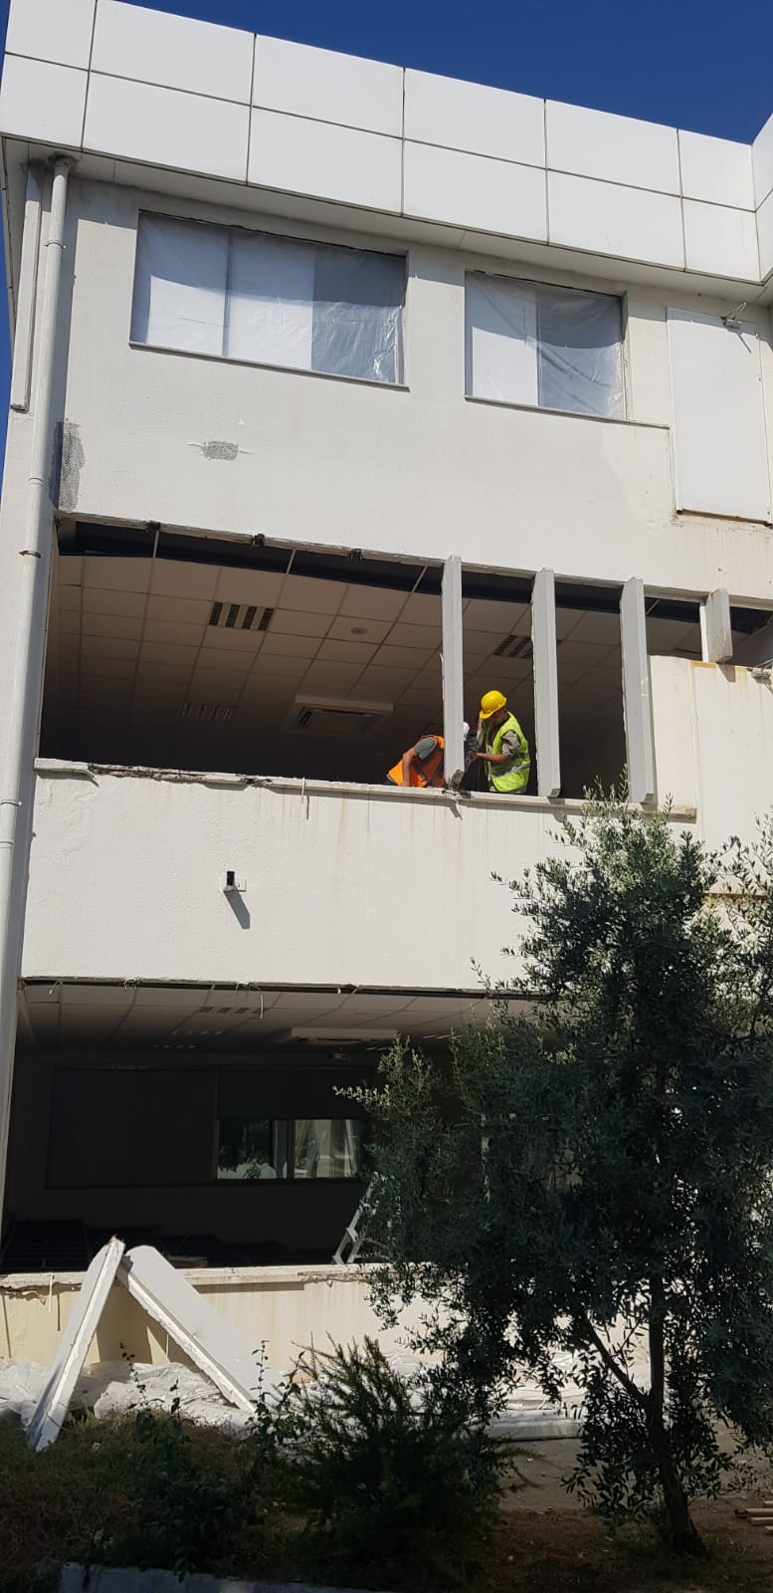

Figure 11: Facade insulation and window replacement at Izmir Bakircay University (August 2023)

An automation system designed for the central lecture hall project was implemented to monitor the energy consumption of buildings, and efforts were made in terms of utilizing energy efficiently through software support and control units. Two separate HVAC (heating, ventilation, and air conditioning) plants were established, integrating heat recovery systems to provide heating and cooling for large lecture halls with reduced energy consumption. In compliance with its efforts on increasing water and energy efficiency in the buildings, Izmir Bakircay University is using energy-efficient mechanical and electrical appliances in the buildings. Replacing traditional bulbs by low energy LED lighting is one of the applications within this scope. In the classrooms, offices and in the corridors all fluorescent lamps have been replaced by LED lighting. Besides there is an automatic light sensor system implemented at the university.

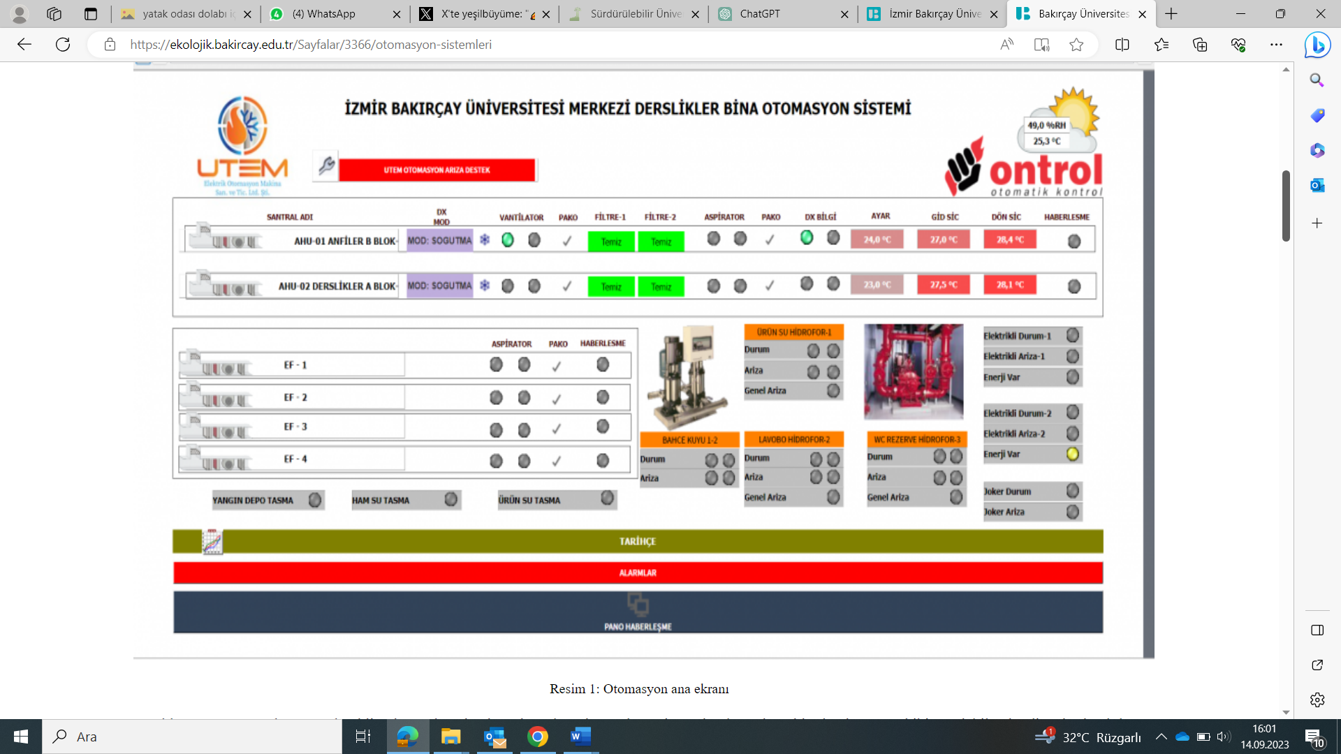

Figure 12: The main display screen of automation system

In addition to existing 400 kWp PV panels and a 100 kW Wind Turbine, a new PV installation of 240 kWh contribute to increase the share of renewable energy use in total energy consumption. The ratio of renewable energy production to total annual energy use is 21%. Additionally, with a project carried out at İzmir Bakirçay University, it is aimed to store rainwater and high-level ground water with the cistern system and use it in environmental irrigation. These project investments will contribute to the university’s mission of becoming energy-independent and meeting its energy demand from renewable energy sources.
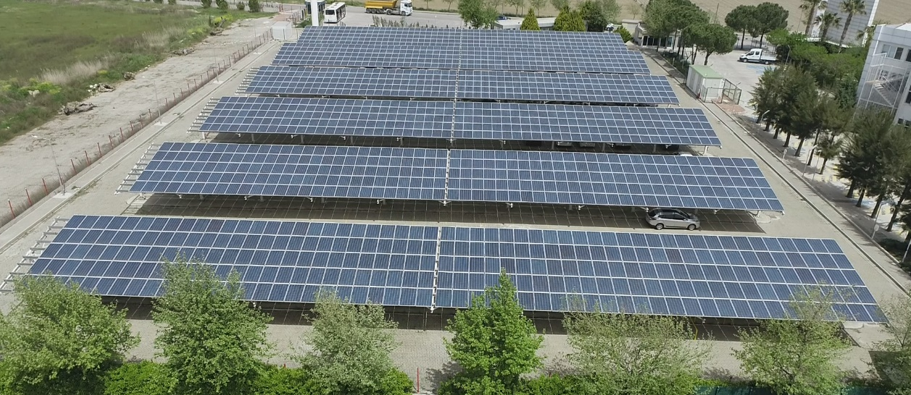
Figure 13: 400 kW PV Panels (roof of the personnel car park at İzmir Bakircay University, Turkey)

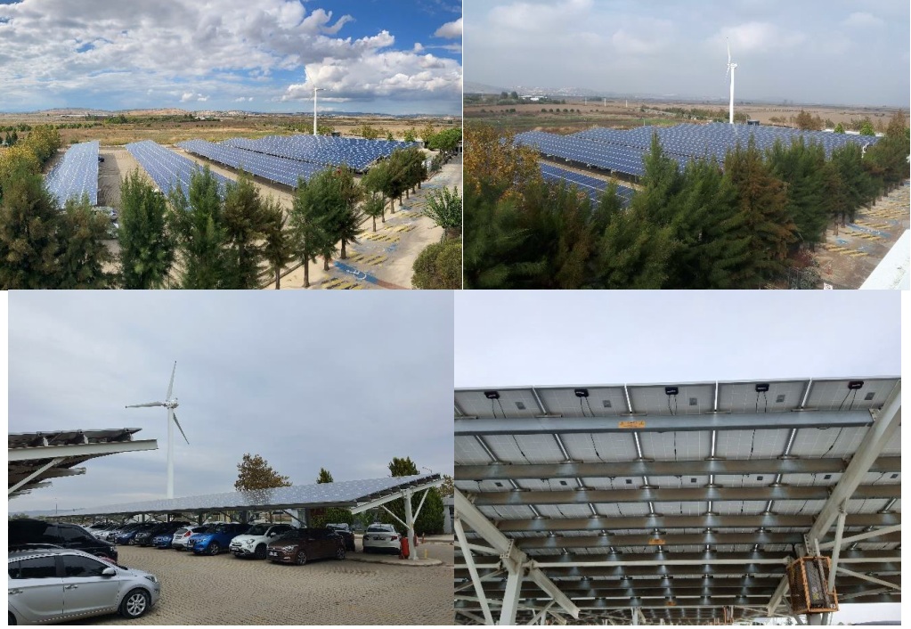
Figure 14: The 100 kW Wind Turbine at İzmir Bakırçay University

In addition, Izmir Bakircay University aims to improve energy savings by various sustainable energy management applications. The energy consumption is monitored, and energy efficient appliances and sensor systems are used throughout the campus area. The ventilation of university buildings, the integration of VRF systems into the curriculum, the use of individual working-shutdown systems, the notification of intelligent system components to the system authority in case of failure and setting of the reminder of periodic maintenance are effectively ensured by the established automation system. Additionally, all buildings have automated systems such as automatic doors, automatic fire alarm systems and automatic lighting.
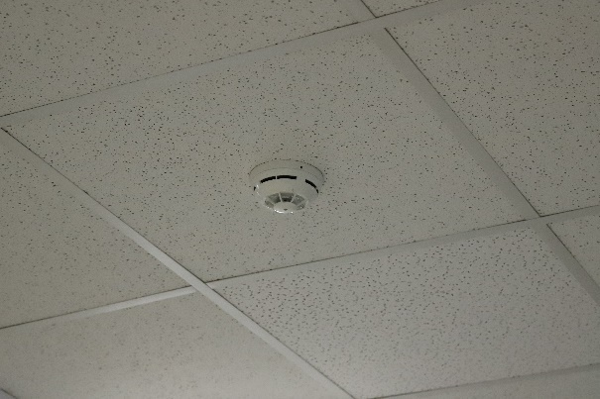
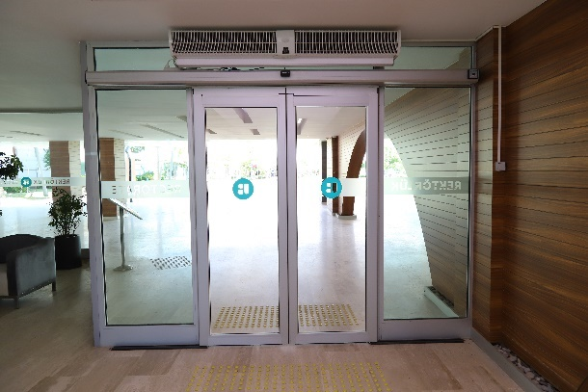

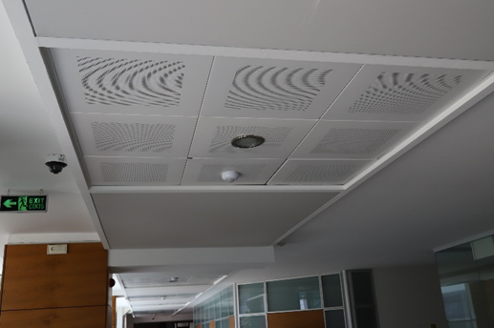

Figure 15: Smart Building implementation (Izmir Bakircay University, Turkey): The Automatic Door Sensor System; The Automatic Fire Alarm Sensor System

4. WASTE
Izmir Bakircay University is a leading higher education institution in Turkey that ensures efficient waste disposal through separation at source. At the campus, special-purpose containers, temporary waste storage areas, and regular collection services are provided to assist students in disposing their waste in a safe and efficient way. Since March 2021, İzmir Bakircay University was awarded the 'Basic Level Zero Waste Certificate' by the Municipality of Environment and Urbanization. This certification demonstrates a commitment to sustainable waste management practices and environmental responsibility. Izmir Bakircay University's efforts to obtain the Basic Level Zero Waste Certificate reflect a dedication to responsible waste management, environmental sustainability, and community engagement. Continuing to build on these efforts and working towards higher levels of waste reduction and sustainability will be essential in the pursuit of a more sustainable future.

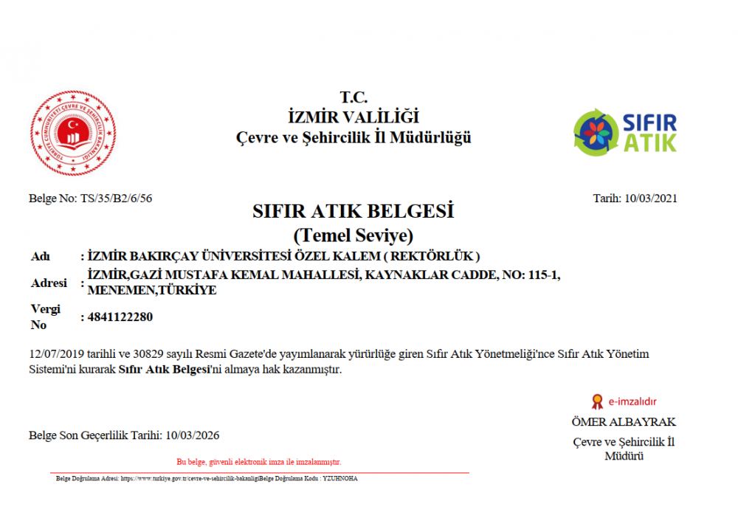

Figure 16: Basic Level Zero Waste Certificate

To obtain the Basic Level Zero Waste Certificate from the Ministry of Environment, Urbanization and Climate Change, Izmir Bakircay University has complied with the following criteria:

- Separate Collection of Recyclables: Izmir Bakircay University has implemented a system to collect recyclable materials like paper, glass, metal, and plastic separately from general waste, promoting recycling and reducing landfill waste.
- Waste Collection Centers and Points: Waste Collection Centers and collection points have been established and are operational, making it convenient for the community to dispose of their waste properly.
- Handling Specific Wastes: The university has developed plans and initiatives to manage different waste streams, including batteries, vegetable waste oil, electrical and electronic equipment waste, medicine waste, and bulky waste, either by directing them to Waste Collection Centers or through specialized collection programs.
- Biodegradable Waste Recovery: The university conducts studies and programs aimed at the separate collection and recovery of biodegradable wastes through composting contributing to reducing organic waste in landfills.
- Awareness and Education: The university actively engages in awareness and education campaigns, raising awareness about the importance of waste reduction and recycling while also collecting data to evaluate the effectiveness of its zero-waste management system.
- Compliance with Regulations: the university aligns its waste management efforts with the provincial Zero Waste Management System Plan, ensuring that its waste management practices are consistent with local regulations and sustainability goals.

Izmir Bakircay University is a leading higher education institution in Turkey that enables effective waste disposal at source.
At the campus, different colored bins and containers, temporary waste storage areas, and regular collection services are provided to assist students in safely and efficiently disposing their waste.
At the campus, waste is categorized into uncontaminated recyclable materials, hazardous waste, electronic waste, batteries, fluorescent lamps, medical waste, textiles, and contaminated packaging. They are separately collected and stored in a temporary waste storage area until the scheduled regular collection dates.
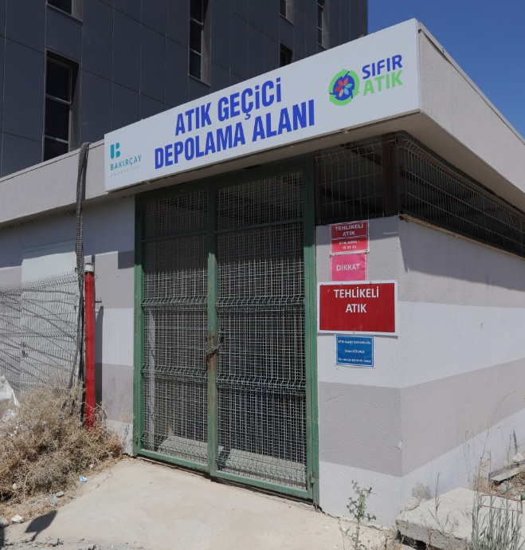

Figure 17: Temporary waste storage area

Environmental protection campaigns are being carried out to raise environmental awareness among the students and academic and administrative staff. Some instances of these campaigns include initiatives such as waste battery collection, fluorescent light collection, plastic cover collection and safe disposal of expired drugs. Additionally, education materials focusing on zero waste and environmental awareness are being prepared for local primary and middle schools, and training sessions are being organized accordingly.
The Turkish Environmental Agency has provided Izmir Bakircay University with financial and technical support amounting to 750,000 TL for the procurement of indoor and outdoor waste bins.
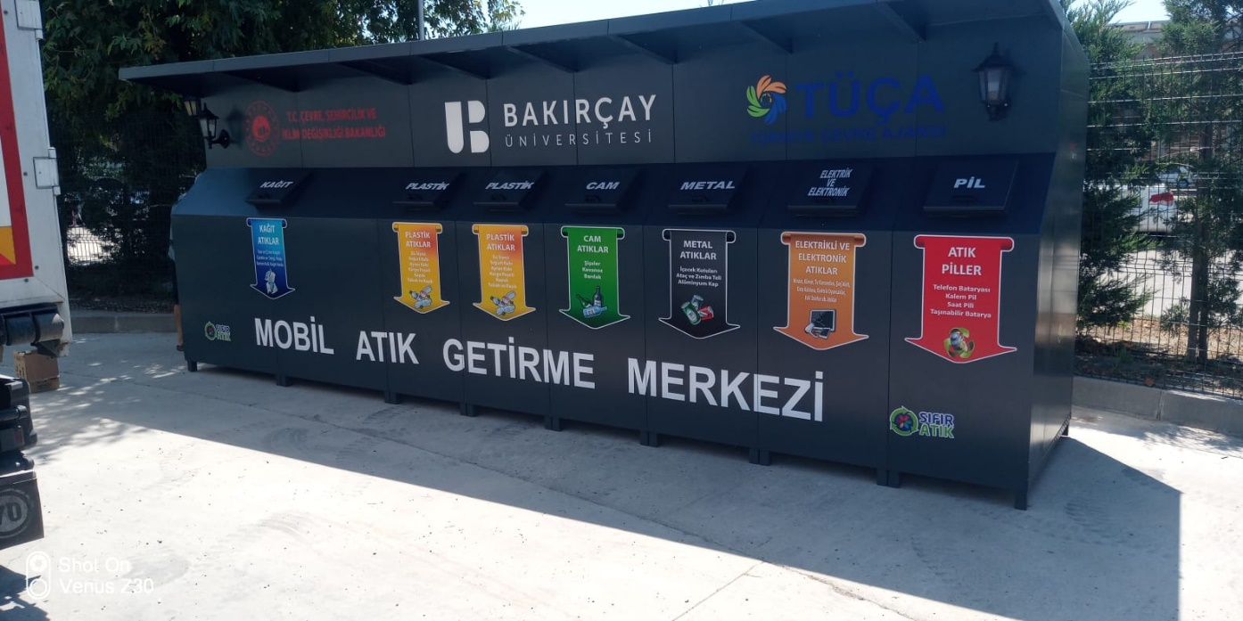
Figure 18: Mobile Waste Collection Center at İzmir Bakircay University

5. WATER
At İzmir Bakircay University, it is planned to store rain and ground water in a cistern system, and thus the use of network water in green field irrigation will be prevented. Utilizing recoverable resources for water consumption will enable reducing the energy consumption and minimizing carbon footprint as well. When evaluated from an economic point of view, considerable savings will be achieved too.
At the campus of İzmir Bakircay University, a hurter irrigation system is used to irrigate plants autonomously. Significant water savings are made on campus by using both drip and sprinkler in terms of efficiency. As a result, waste is avoided by reflecting on invoices and waste in front of economic development is prevented. Both irrigation methods have different advantages in providing the necessary water for plants. Drip irrigation promotes water conservation and can help reduce plant diseases, while sprinkler irrigation offers a fast and efficient way to irrigate large areas. The choice of irrigation method can vary depending on the farmer's needs, plant type, and the climate conditions of the region being cultivated.

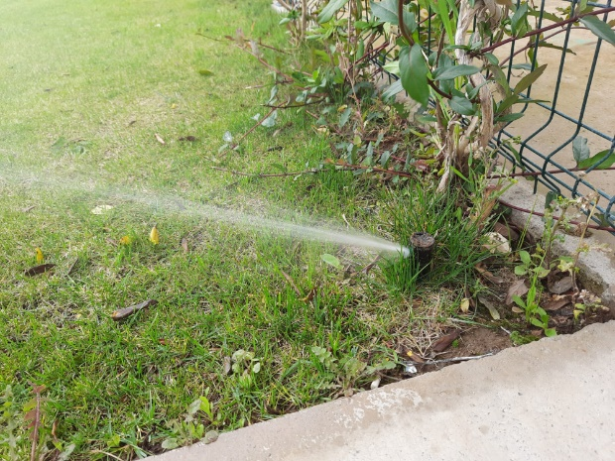
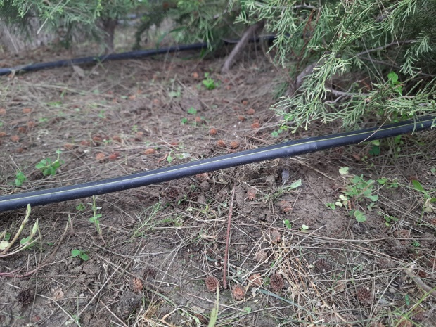

Figure 19a: Drip irrigation method Figure 19b: Sprinkler irrigation method

The Use of Water Efficient Appliances in the campus buildings:
Flow rate decreasing appliances for water taps are used in all the campus WCs. In addition, all the WCs are provided with low flush toilet equipment. Motion-activated hand washing taps were installed throughout the campus to reduce water consumption.
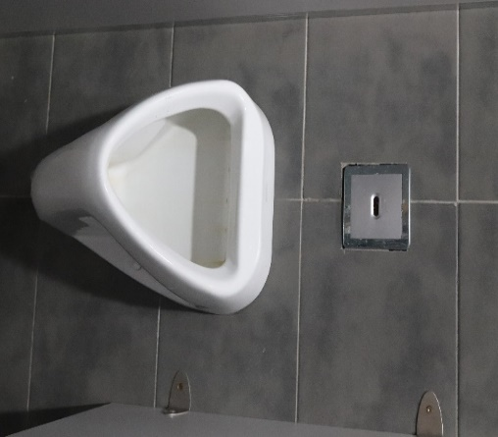
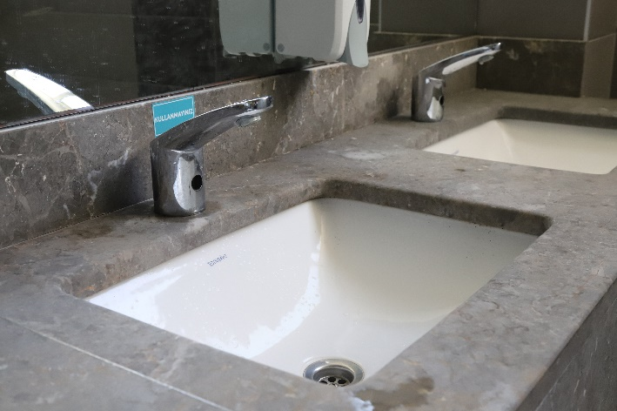

Figure 20: Example of Water Efficient Appliances Usage (İzmir Bakircay University)

Table 1: Motion activated water faucets
Appliance | Total Number | Total number water Efficient appliances | Percentage
Taps | 183 | 268 | 68.3 %

6. TRANSPORTATION
Izmir Bakircay University is located 39 km away from the center of Izmir, and transportation to İzmir Bakircay University has been facilitated thanks to Izmir's advanced transportation options. İzmir Bakircay University is located 8 kilometers away from the Ulukent station, and it is easy to reach the university via 5 different ESHOT buses from the Ulukent station. The services starting from 05:50 in the morning continue until 00:00 at night. Continuous improvements in public transportation have aimed to reduce carbon emissions by encouraging people coming to school to use public transportation.

Every year a protocol is signed between a transportation company and the University for transporting campus members for free from seven different locations of the city, Izmir, to the university in the morning and reverse direction in the afternoon. The bus is operated by the university rectorate and one can take the bus with online daily registration from the university webpage free of charge. These campus bus services correspond to more than a 30% reduction in private car usage on campus. With its shuttles, Bakircay University encourages public transportation by reducing the use of private vehicles. In this way, the carbon footprint of Bakircay University also decreases.

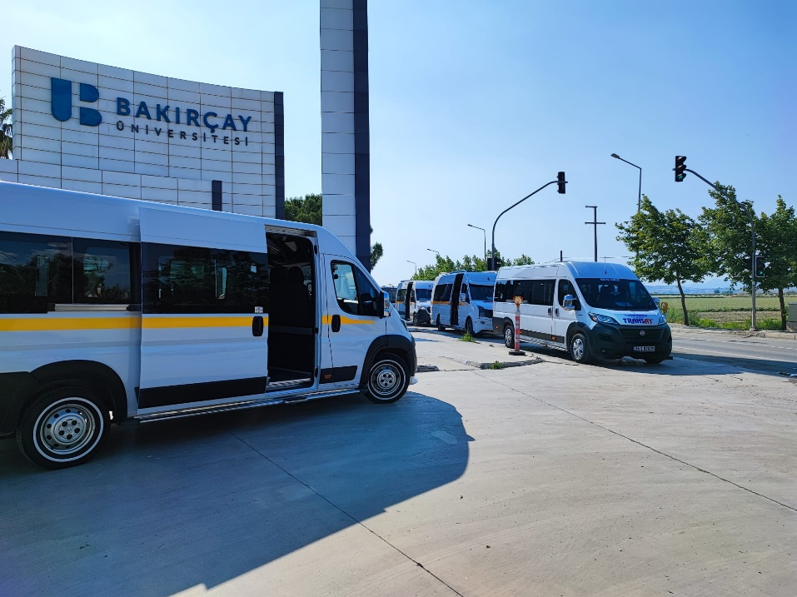

Figure 21: Shuttles in front of Bakircay University

7. EDUCATION AND RESEARCH

As a leading public university, Izmir Bakircay University aims to integrate principles of sustainability into its innovative research and education activities. At the university, the ratio of courses related to sustainability including the undergraduate and graduate studies over total courses is 14. These courses are offered in engineering, natural sciences, law and medicine faculties and also in economics and management departments as well as Vocational School of Justice. In 2022, total sustainability budget was 6541240 USD, with a percentage of 81%. Funds allocated to sustainability activities are expected to increase in the next years.
It is noteworthy to mention the student organizations and sustainability related events that exist in the campus to understand the social dimension of sustainability in Izmir Bakircay University.
İzmir Bakircay University Student Council and Clubs Union is an official unit affiliated to the Rectorate, which organizes meetings where it observes student rights and promotes the educational, health, sports, and cultural needs of students at the university. İzmir Bakircay University is a university which not only offers its students a very good education but also provides them many opportunities to realize their ideas. There are 33 clubs established by the students on various subjects and the University ensures that the students socialize and gain experience in the areas they are interested in as well as they realize their hobbies. The student clubs are managed by a directive published by the university in a transparent way. There are 13 student organizations in the university that are related to sustainability.

- IEEE Bakircay Student Community
- Hiking and Extreme Sports Society
- Disability-Free Life Community
- Idea Development Community
- Entrepreneurial Leaders Community
- Camping and Scouting Society
- Volunteer Community
- Young Kizilay Community
- Artificial Intelligence Community
- Animal Friends Society
- Excursion Society
- Ecology Society
- Young Yesilay Society

